Harbor Heartbeat User Manual

Waterfront Partnership of Baltimore, Healthy Harbor Initiative

650 S. Exeter St, #200

Baltimore, MD 21202

Author: Eileen McMahon

Eileen@waterfrontpartnership.org

7/19/2018

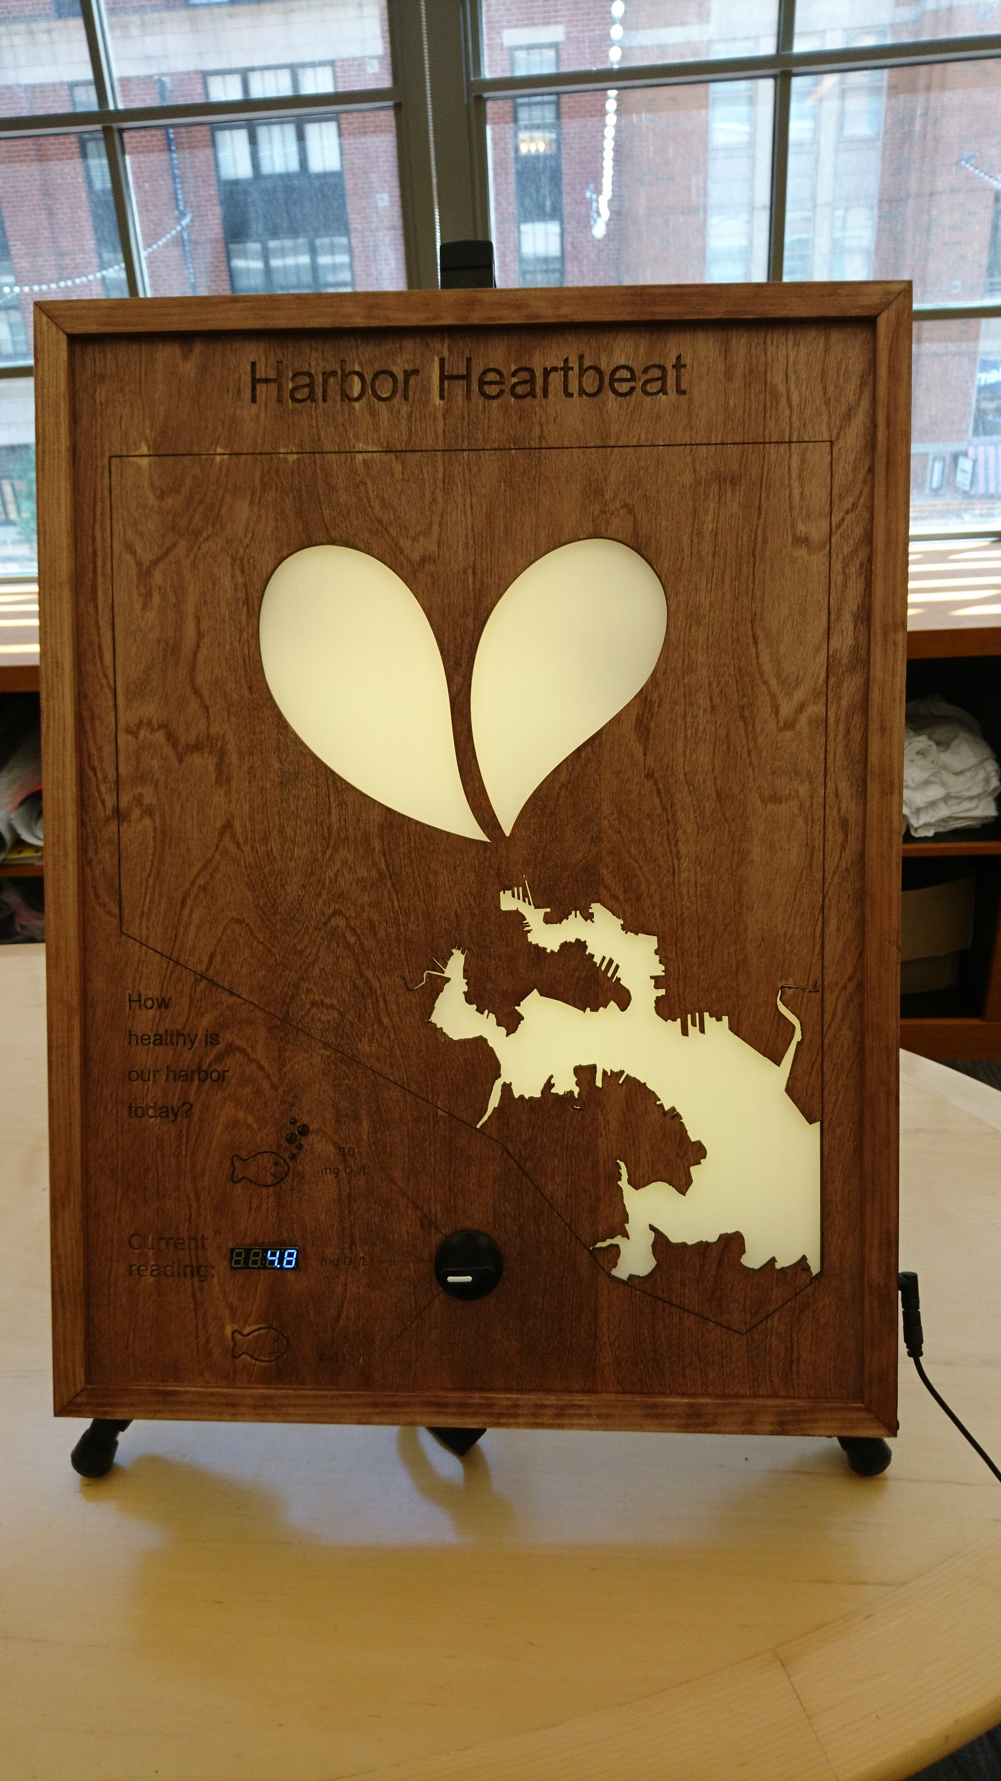

# Harbor Heartbeat Overview

The Harbor Heartbeat is an artistic educational tool to demonstrate real-time changes in the health of the Baltimore Harbor. The “Heartbeat” changes color and beats per minute based on the current health of the Harbor. If there is lots of oxygen for fish to breathe, the “Heartbeat” will be blue and slow. Oxygen levels that are still good but lower get greener and slower, whereas if the levels are poor to harmful the Heartbeat will range from yellow to red and beat rapidly. The goal of the project is to transform readily available data into some form that’s easily understandable, and catches attention.

There are two working versions – one referred to as the Full Scale Version and one referred to as the Prototype Version.

Each version displays live readings, as well as comparison readings for preset values. Both devices compare to 5 mg/L, as that is a target value for dissolved oxygen to be considered good. The maximum scale of DO readings was adjusted between the two versions – the prototype version maxes out at 15 mg/L, and the full-scale version displays 10 mg/L as a maximum.

# Harbor Heartbeat – Full Scale Device

## Matierials

Harbor Heartbeat Full-scale device

Verizon Wireless Hotspot

Hotspot Charger

Option 1 – 12V 5 A power supply, 5.5x2.1 cable with 2.1 – 2.5 angle adapter

Option 2 – Connect port or adapter to 12 V battery, capable of at least 4 amps.

## Mounting and Set-Up

The Full Scale Device can either be mounted to a wall using the French Cleat provided with the device, or can be displayed on an easel.

The French Cleat uses one piece of wood mounted to the device, and one piece of wood that gets mounted to the wall. To keep the pieces together when not in use, the wall-mounted cleat is attached to the back as well using two Phillips head screws. Refer to Figure 1 for which piece is the wall side.

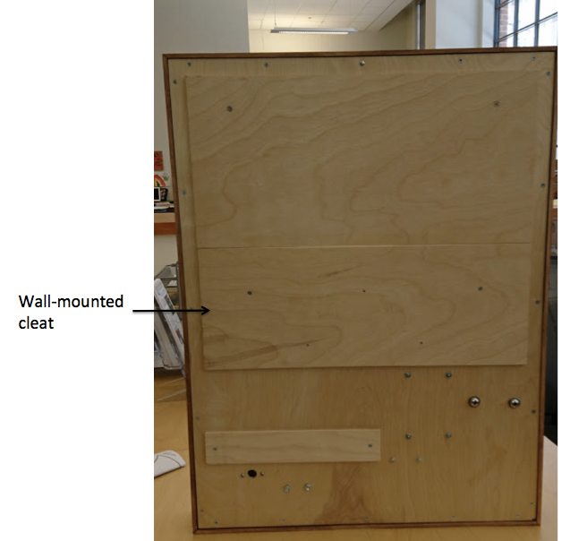

Figure : French Cleat

## Starting Up the Device

The full-scale device is configured to run off of a wireless hotspot. The Wireless hotspot must be started up before powering on the Harbor Heartbeat device.  **Note: The hotspot takes considerable time to start up.** Wait until the hotpot displays signal and battery info.

Once the wifi is set up, plug in the device to power. The power port is on the lower right side of the device. The device can be plugged into a 12V power supply or a 12V battery capable of at least 4 amps of current.

**Note:** The battery and power supply used for the Prototype does not supply enough current for use with the full-scale device.

## Troubleshooting

The serial display could alert you to two possible error conditions.

|  |  |  |
| --- | --- | --- |
| **Error** | **Cause** | **Resolution** |
| E1 | The device was unable to connect to the WiFi network | Ensure the wifi hotspot is on and has signal. Disconnect and reconnect device from power. |
| E2 | The device is connected to the WiFi, but unable to read the site. This occurs if the device is turned on before the hotspot has started up fully, or if the hotspot is out of data. This could also occur with poor signal strength. | If the hotspot has strong signal and is close to the device, cycle power and see if the error persists. If so, contact Waterfront Partnership to refill the hotspot. |
| Unexpected letters or no display, no lights | Occasionally other errors may occur on start up. If the device takes more than a minute to display a reading or blink, try starting the device up again. |  |

# Prototype Device

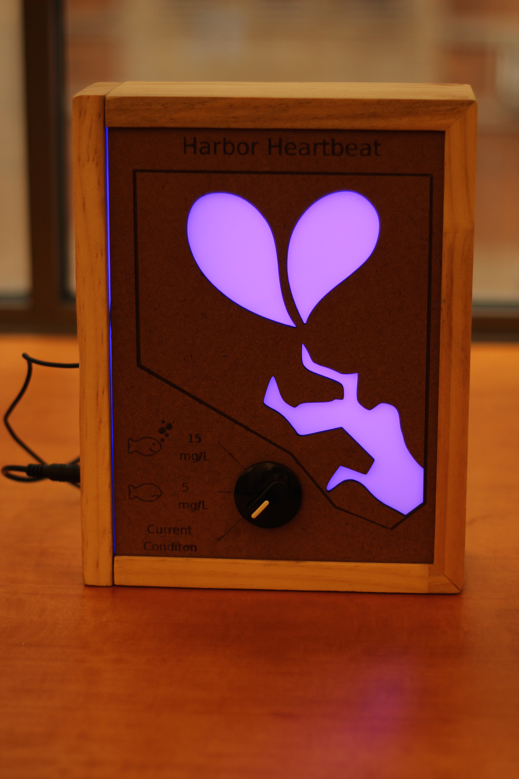

## Materials

Prototype device

12V 2A battery pack with cord

Battery pack charger

Verizon Wireless Hotspot

Hotspot Charger

## Quick Start

The prototype device requires a WiFi hotspot and two separate power cables. The Wireless hotspot must be started up before powering on the Harbor Heartbeat device.  **Note: The hotspot takes considerable time to start up.** Wait until the hotpot signal and battery info.

For the Prototype device to run, the USB cable and the round DC power cord must be plugged in. Both can run off the provided battery pack. Note that this battery pack is not strong enough to power the full-scale version.

# Differences between Full-Scale and Prototype Version

|  |  |  |
| --- | --- | --- |
| **Feature** | **Full-Scale** | **Prototype** |
| Power connectors | Only needs one 12 V power cord  (5.5 x 2.1 mm cord with adapter or 5.5 x 2.5 mm power cord) | Needs power to the USB and the 12V DC power cable (5.5 x 2.1 mm) |
| Current requirements | 2 Amps | 5 Amps |
| Current Reading Toggle | Current reading mode is the middle option | Current reading is the bottom option |
| Scale Maximum | 10 mg/L | 15 mg/L |
| Digital Display | Includes a digital reading of the current dissolved oxygen levels | No digital reading |

# Updating the software

## Required software

### CP210x driver

Install the Mac OS X version of the CP210x driver found here: <https://www.silabs.com/products/development-tools/software/usb-to-uart-bridge-vcp-drivers>

The download is a zipped folder that acts like a virtual CD when opened (a .dmg file).   Inside the .dmg file is folder named Legacy MacVCP Driver. Use the “Silican Labs VCP Driver.pkg” found within the Legacy folder, rather than the main folder.

### Arduino IDE Installation and Setup

1. Download and install the Adruino IDE from here: <https://www.arduino.cc/en/Main/Software>
2. Once the installation is complete, open up the Arduino software.
3. Go to Arduino -> Preferences

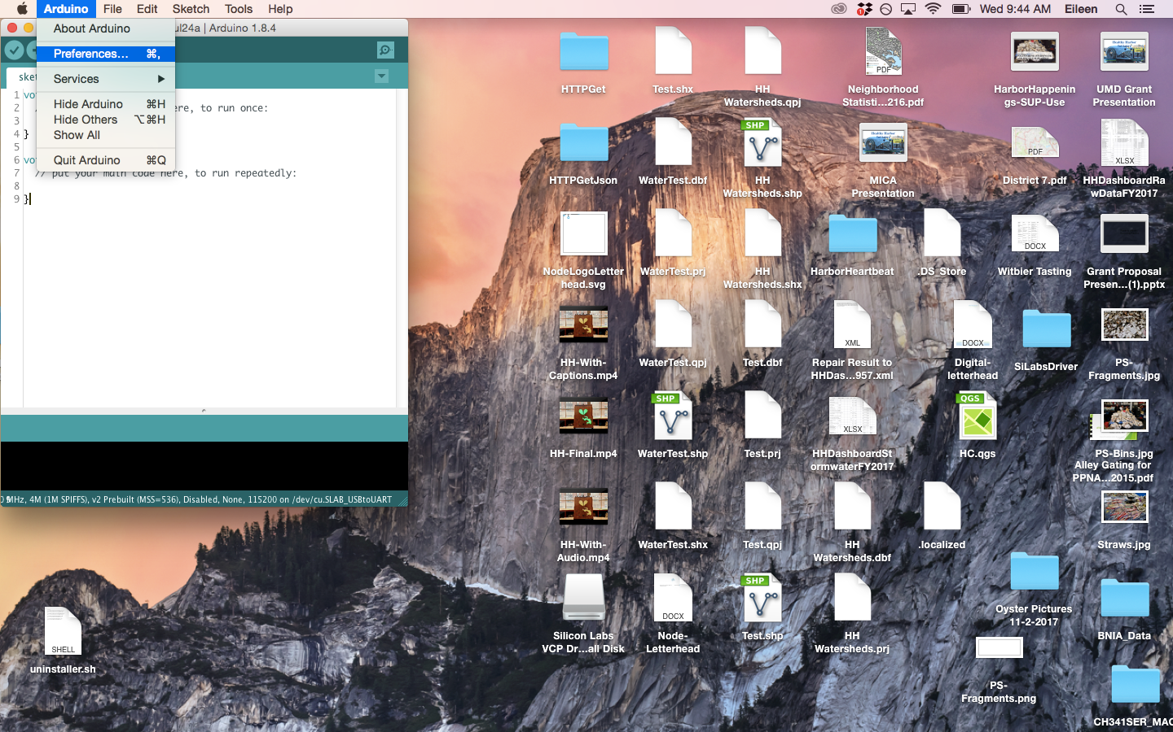

1. In the dialog that pops up, copy <http://arduino.esp8266.com/stable/package_esp8266com_index.json> into the “Additional Boards Manager URLs” box, and hit OK.

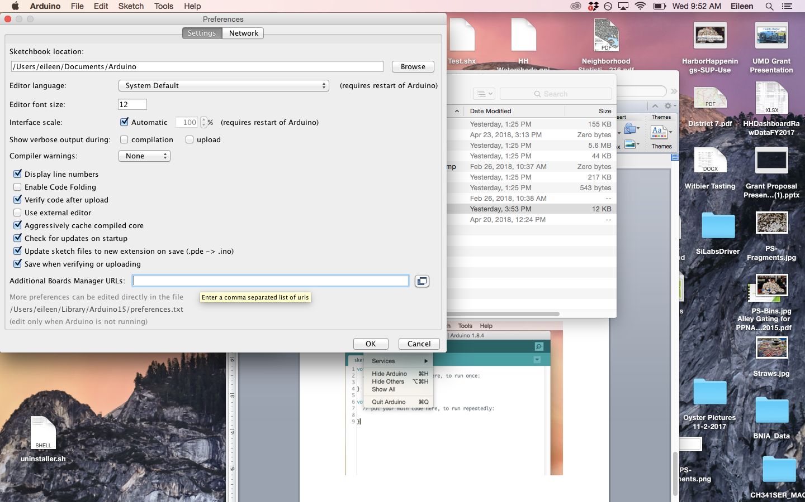

1. Close and reopen the Arduino program.
2. Change the settings in the Tools tab as shown. Note that the Port setting can only be changed when the device is plugged in. The settings are:

Board -> NodeMCU 1.0 (ESP-12E Module)

Flash Size -> 4M (3M SPIFFS)

CPU Frequency -> 80 Mhz

Upload Speed -> 921600

Port -> /dev/cu.SLAB_USBtoUART (this can be configured later if the device is not yet connected)

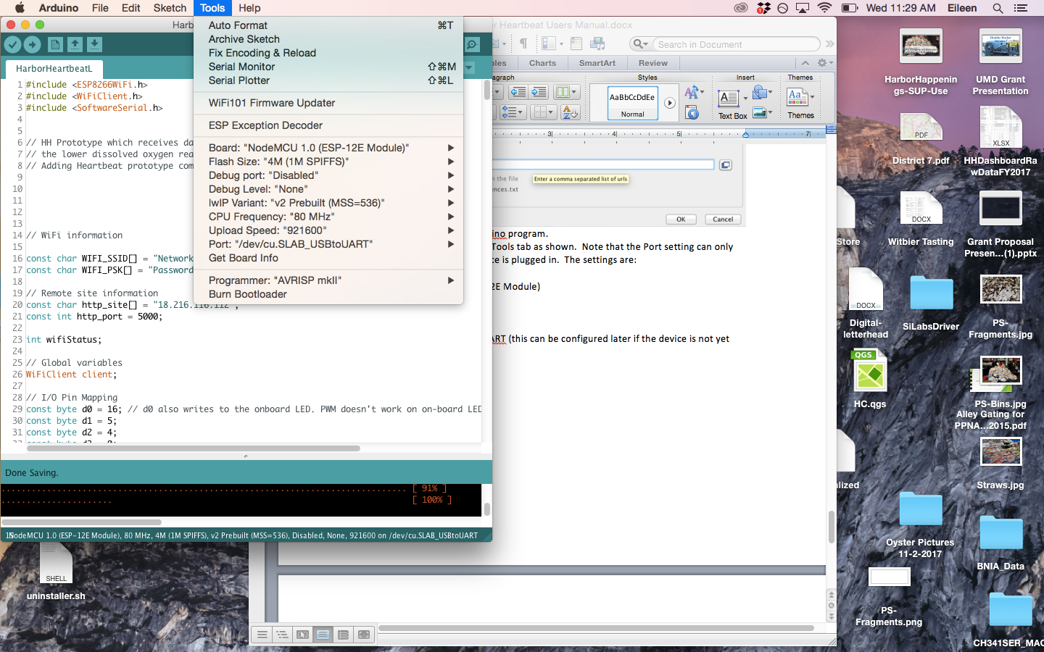

## How to Upload

The Harbor Heartbeat will continually run whichever Arduino sketch was last uploaded to it. To upload a sketch, make sure the device is connected through your computer with the USB, and that the Arduino Port setting (Tools->Port) is set to “/dev/cu.SLAB_USBtoUART”.

Upload the desired sketch using the Upload arrow on the upper right of the sketch window. The arrow button will turn white when clicked as shown in the picture below.

Once pressed, it will take a moment for the file to compile then upload. Wait to disconnect the USB until after the dialog at the bottom of the sketch says “Done Uploading.”

## Updating WiFi information

The software which runs the Harbor Heartbeat is called “HarborHeartbeat.ino”. To make changes to the WiFi information, use this file and make changes to the following lines, which are at the top of the sketch:

const char WIFI_SSID[] = "Network Name";

const char WIFI_PSK[] = "Password";

When editing the “Network Name” and “Password”, make sure that the new settings are still in quotations and that the semicolon is still in place. Then upload using the arrow on the upper left corner.

## 